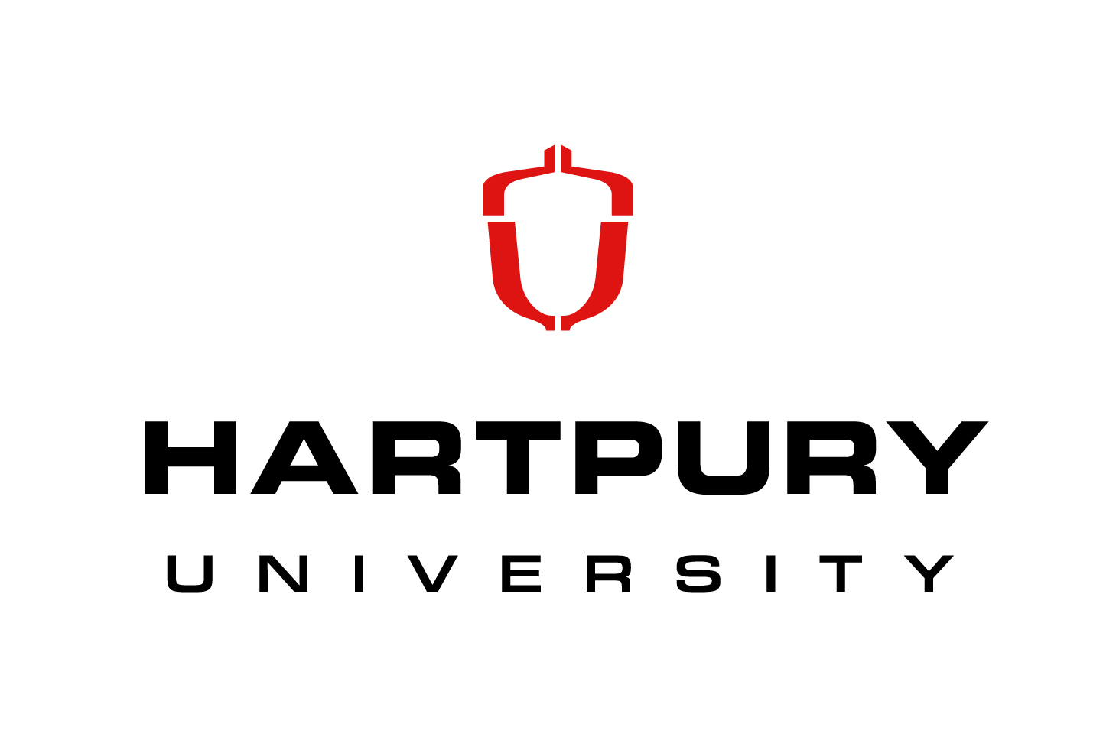
Postgraduate Teaching Assistants
Animal and Agriculture, Equine, and Achievement and Success Centre
Fixed Term from September 2024 until June 2025
£11.44 per hour

With over 1500 students studying degrees at foundation, honours and postgraduate level,
Hartpury presents a unique environment designed to support an outstanding student experience, through industry relevant provision, informed by staff with strong professional links and research activities. This is underpinned by access to specialist facilities, which are fully utilised to enhance delivery and support the employability of our graduates.

This scheme offers full-time Hartpury University postgraduate taught students paid employment within a range of HE academic departments. Each post comprises a term-time contract of 15 hours a week with post holders studying alongside their work responsibilities. Each Assistant will complete a full induction programme and receive ongoing continuing professional development opportunities throughout the year, while adding a distinctive range of workplace responsibilities to their CVs. As such, the scheme offers the ideal opportunity to subsidise postgraduate study fees, while developing a range of transferable skills that are highly prized by potential future employers.
Current opportunities include administrative and practical teaching roles in the Animal and Agriculture and Equine Departments, and the Achievement and Success Centre. Current opportunities are available for individuals who are due to be enrolled on a postgraduate taught programme from September 2024.

We are committed to safeguarding and promoting the welfare of children and young people and expect all staff and volunteers to share this commitment. We will ensure that all our recruitment and selection practices reflect this commitment. All successful candidates will be subject to Disclosure and Barring checks along with other relevant employment checks.

Please email human.resources@hartpury.ac.uk for an application form.

The closing date for receipt of applications is 21st July 2024. Interviews will be held on 29th July 2024 and successful applicants should be able to start in post from 2nd September 2024.

Hartpury values a diverse workforce and welcomes applications from all sections of the community.

