Meerkat (*Suricata suricatta*)

The Meerkat is a small omnivorous mammal, they are part of the mongoose family and live in Southern Africa (Botswana, Namibia and South Africa).

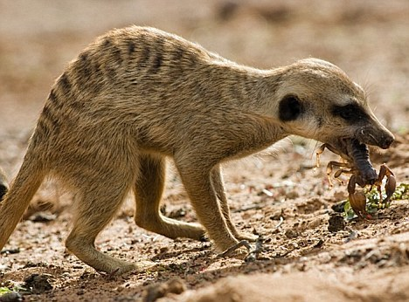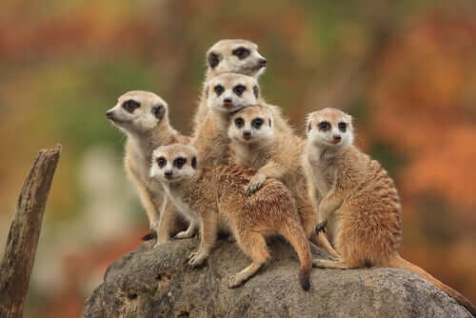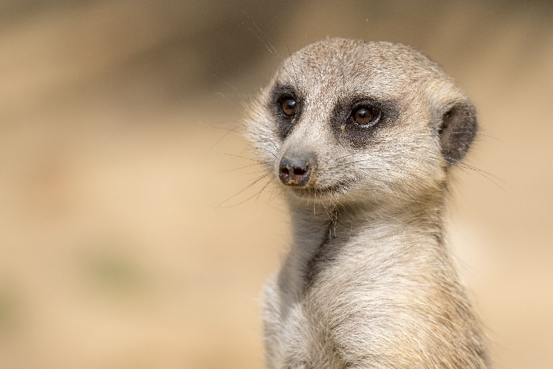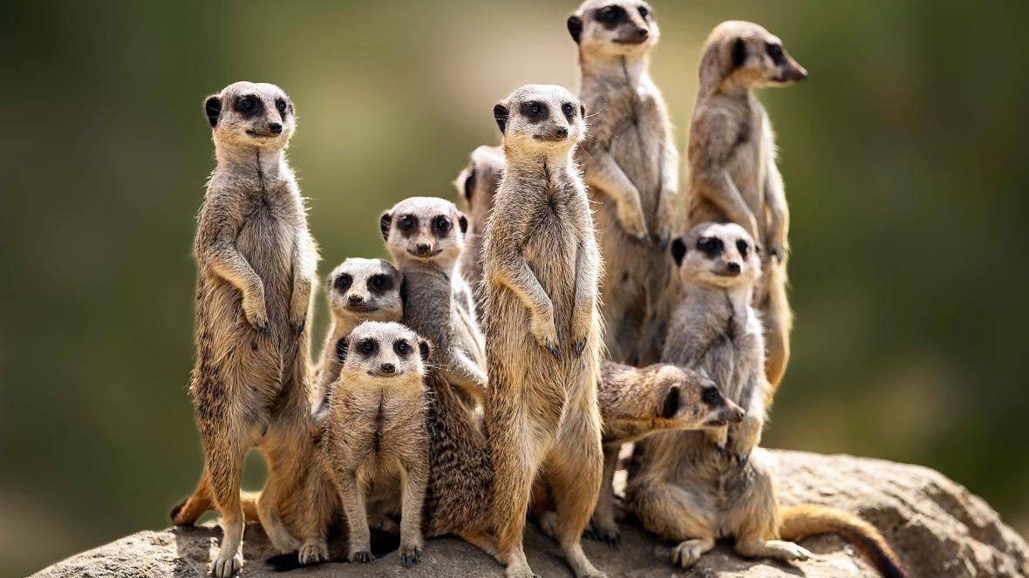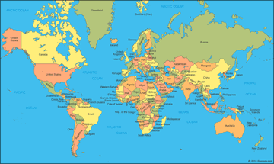

Meerkats are very active animals and can live up to 13 years in the captive environment (up to 8 years in the wild environment).

There are three subspecies of meerkat based on the area they live in, each looks very similar; *Suricata suricatta iona, Suricata suricatta majoriae* and *Suricata suricatta siricata.*

A female meerkat can have 2-8 offspring (pups) at a time. Often it will be the dominant female (alpha) who reproduces and the other members of the social group will help to raise the offspring. This may involve keeping them warm, feeding them and also teaching them to hunt. They will be fairly independent by around 11 weeks of age and are able to reproduce themselves by just 18 months of age!

Meerkats work together really well; one meerkat will stand on “sentry duty” and look out for danger whilst the other meerkats forage for food or look after their offspring. They will take it in turns to do this so that everyone has enough time to find food.

Lots of foods are eaten by meerkats, they will eat small lizards and birds (and bird’s eggs) as well as fruits and plants. Meerkats also sometimes eat poisonous scorpions as they have some immunity to the venom.

Meerkats live in deserts and grasslands where they build tunnel systems underground to keep them safe from predators and to rest and raise their young. They live in social groups of around 20 individuals but it is possible for them to live in much larger groups with up to 50 individuals! The social group is called a mob.

Meerkats will usually spend the first part of the day sunbathing, to do this they stand on their back legs and face in the direction of the sun. The dark patches around their eyes reduce the glare of the sun and help them to see clearly when it is really sunny.