Rabbit (*Oryctolagus cuniculus*)

Rabbits are one of a few species which can be found living around the world in a variety of habitats; the only continent where rabbits have not been found is Antarctica although the European Rabbit is the most common species.

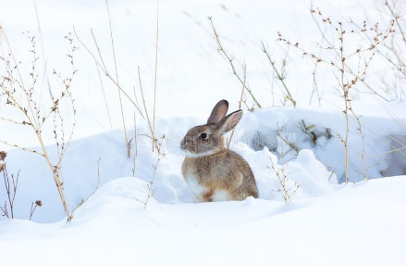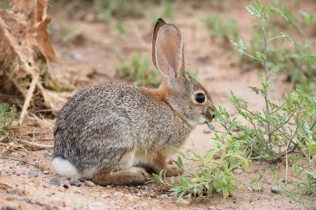



Rabbits are herbivorous animals which forage for up to 8 hours a day on grasses, weeds and wild flowers.

Rabbits live in large groups known as colonies with both females (does) and males (bucks) as well as their offspring (kit). A rabbit can have offspring at just 6 months of age and the day after she has given birth she can get pregnant again, this means one rabbit can produce up to 1000 offspring in her lifetime.

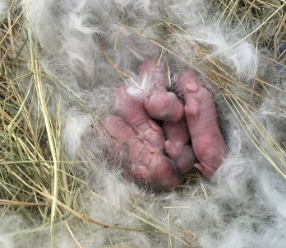



When a rabbit is born, it doesn’t have any fur and cannot see or hear. They are very dependent on their mother for the first three weeks of life; they shouldn’t be handled or picked up by a person.

Rabbits are the third most common companion animal within the United Kingdom, there were estimates of over 900,000 being kept as pets in 2019. They are popular because they are social and adapt to humans well.

In the wild environment rabbits have to always be looking out for danger, lots of other animals (such as foxes, badgers and birds of prey) will eat rabbits and so they have to work together in order to stay alive. When rabbits are foraging, they will warn each other of danger; their white tail acts as a warning signal. Rabbits vision covers nearly 360 degrees so they can see all around them.



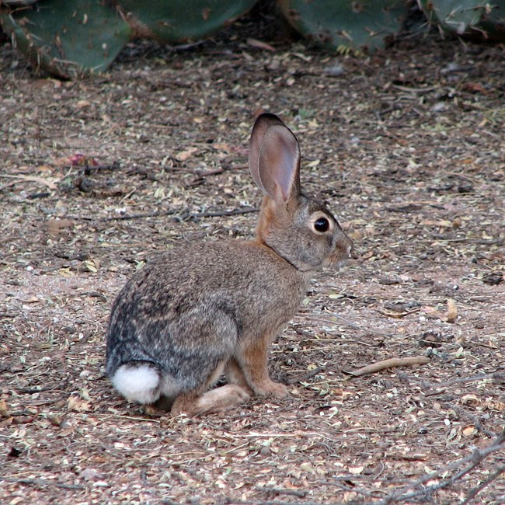

There are around 30 different species of rabbit around the world. There are also lots of different breeds of rabbits which are kept as companion animals with the Lionhead, English lop and the Dutch rabbit amongst the most popular in the UK.