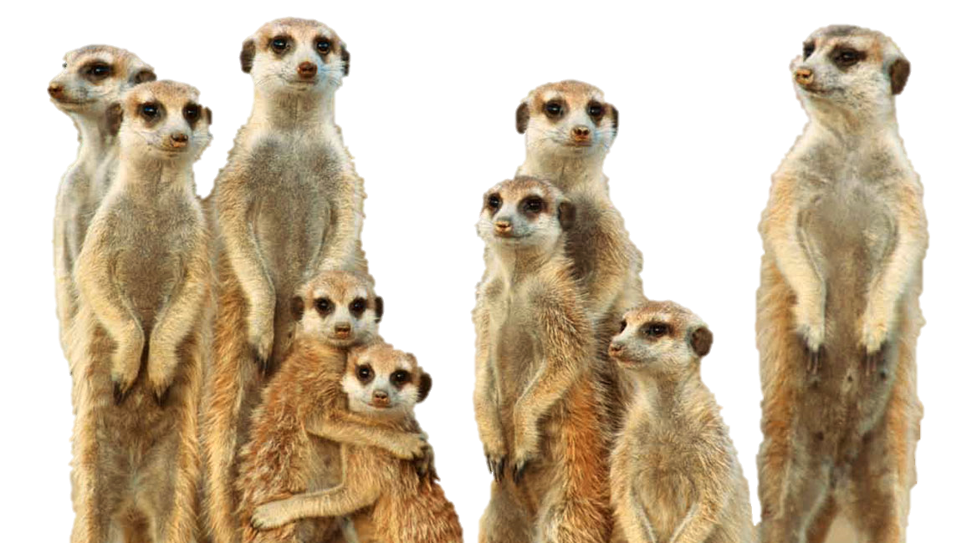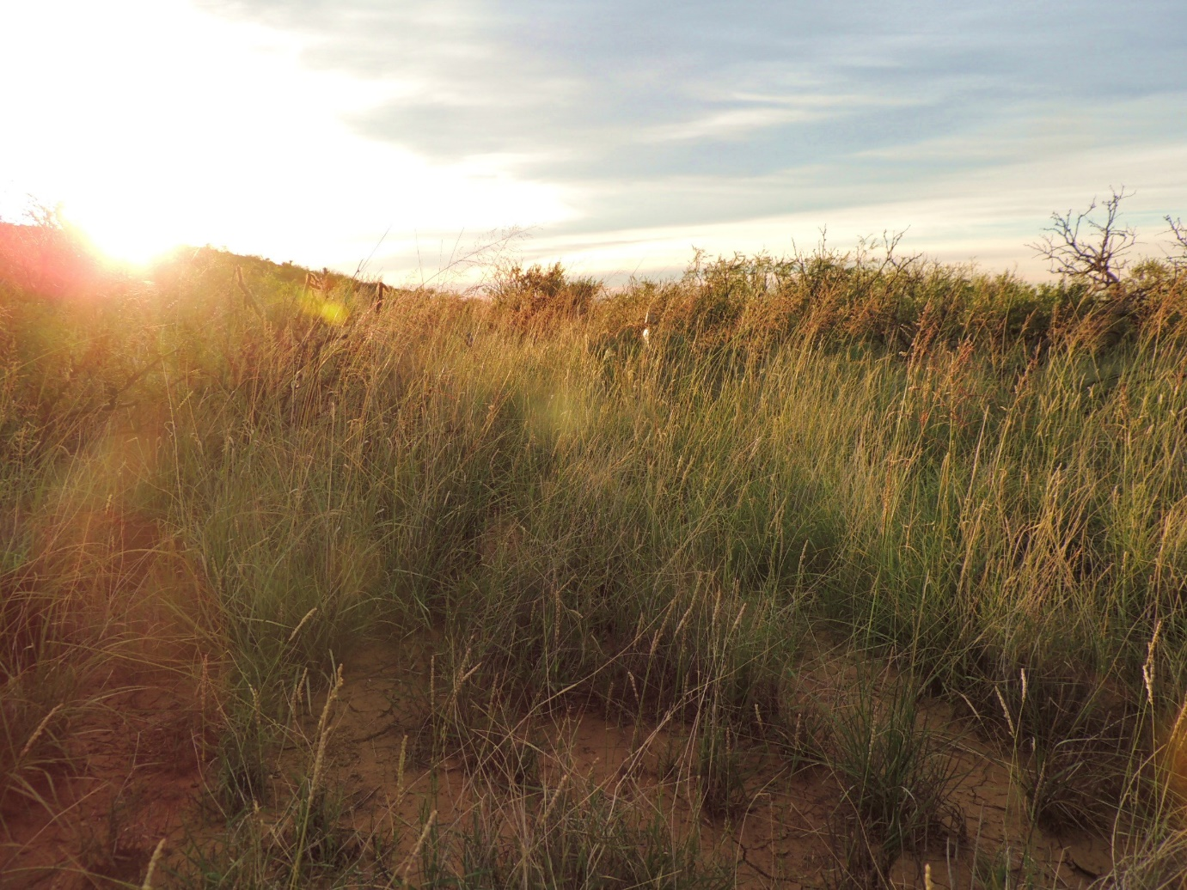

|  |  |  |  |  |  |  |  |  |  |  |  |  |  |  |  |
| --- | --- | --- | --- | --- | --- | --- | --- | --- | --- | --- | --- | --- | --- | --- | --- |
| **C** | **O** | **N** | **S** | **E** | **R** | **V** | **A** | **T** | **I** | **O** | **N** | **N** | **Y** | **O** | **N** |
| **W** | **B** | **T** | **H** | **E** | **R** | **A** | **P** | **Y** | **L** | **F** | **Q** | **Z** | **L** | **O** | **C** |
| **K** | **B** | **E** | **B** | **H** | **X** | **J** | **U** | **A** | **A** | **N** | **C** | **C** | **I** | **G** | **U** |
| **S** | **K** | **Y** | **H** | **Y** | **R** | **J** | **A** | **B** | **N** | **L** | **D** | **T** | **V** | **Z** | **G** |
| **G** | **C** | **Z** | **M** | **A** | **C** | **W** | **S** | **V** | **M** | **U** | **C** | **Y** | **E** | **K** | **Q** |
| **Z** | **N** | **O** | **Y** | **Z** | **V** | **E** | **C** | **B** | **O** | **E** | **D** | **Y** | **S** | **Y** | **U** |
| **H** | **I** | **I** | **H** | **I** | **I** | **I** | **A** | **G** | **L** | **L** | **H** | **W** | **T** | **R** | **W** |
| **M** | **I** | **K** | **N** | **C** | **F** | **V** | **O** | **L** | **I** | **M** | **N** | **W** | **O** | **K** | **N** |
| **N** | **J** | **W** | **E** | **I** | **K** | **D** | **O** | **U** | **E** | **H** | **D** | **L** | **C** | **Z** | **W** |
| **Q** | **H** | **P** | **A** | **U** | **A** | **C** | **T** | **E** | **R** | **J** | **H** | **Q** | **K** | **H** | **W** |
| **O** | **S** | **Q** | **N** | **L** | **L** | **R** | **R** | **R** | **E** | **S** | **E** | **A** | **R** | **C** | **H** |
| **P** | **K** | **F** | **W** | **A** | **Q** | **K** | **T** | **K** | **D** | **P** | **A** | **R** | **T** | **P** | **C** |
| **H** | **S** | **N** | **M** | **M** | **A** | **A** | **D** | **M** | **I** | **O** | **L** | **J** | **V** | **Q** | **A** |
| **G** | **I** | **I** | **D** | **T** | **E** | **X** | **S** | **N** | **S** | **Y** | **T** | **X** | **F** | **C** | **J** |
| **E** | **N** | **K** | **S** | **R** | **S** | **I** | **K** | **E** | **E** | **Q** | **H** | **R** | **I** | **F** | **V** |
| **A** | **M** | **O** | **A** | **M** | **T** | **O** | **K** | **J** | **A** | **U** | **Z** | **M** | **G** | **Z** | **Z** |
| **X** | **W** | **Y** | **A** | **E** | **E** | **D** | **B** | **B** | **S** | **G** | **W** | **I** | **C** | **S** | **V** |
| **T** | **F** | **I** | **E** | **B** | **A** | **L** | **W** | **W** | **E** | **L** | **F** | **A** | **R** | **E** | **T** |

*Find these words:*

Animal Collection

Behaviour

Conservation

Disease

Health

Livestock

Meerkats

Research

Species

Therapy

Training

Welfare

***Write your name:* ­­­­­­­­­­­­­­­­­­­**

_____________________________________