

Car Parking Management Policy

1. General Policy Statement

Hartpury has a generous amount of car parking around all main areas of the estate and, for the majority of the time; this is more than adequate to cope with the parking demands placed on the campus. However, with ever-increasing student numbers, the pressure on the available spaces will also increase, therefore, a clear & concise policy is required to ensure all staff, students, contractors and visitors understand the parking regulations.

Hartpury has a variety of parking options on campus, designed to support students, staff and visitors in parking safely and appropriately. In order for this to be achieved, users of the parking facilities are required to engage with this policy.

2. Scope

This document outlines the car parking policy for all parts of the estate and applies to all road users including; motorists, motor cyclists and cyclists. As well as complying with the current Road Traffic Act Legislation whilst on Hartpury owned or leased land, all students, staff and visitors are also required to comply with Hartpury’s regulations of which the car parking policy forms a part.

3. Policy Statement

3.1 Hartpury cannot guarantee parking facilities to staff, students or visitors to the campus unless they are driving a Hartpury owned or Hartpury leased vehicle. All parking permits are issued on a ‘first come, first served’ basis within designated areas. Once all permits have been issued for a designated area, students will be offered alternative parking options, which may not be close to their preferred choice. Vehicles may only be parked on campus premises when on official business, are registered with the Transport Department or, in the case of visitors, have signed in at the appropriate reception; main Reception (Student Zone), Facilities office, Equine Arena office and Home Farm Dairy office and Sports Academy.

3.2 Users of the campus car parks do so at their own risk and the organisation cannot accept liability for accident, loss or damage to vehicles (or occupants/contents) howsoever caused. Granting permission to park by a Hartpury employee does not constitute any admission of liability.

3.3 Hartpury, in line with its sustainability policy has provided a total of 42 electric charging points for all students, staff and visitors (location details on Page 7).

4. Parking Permits

4.1 Hartpury operates a system of parking permits for students, staff, members of the Corporation and visitors. Parking permits allow quick and effective identification of vehicles and allow College staff to contact vehicle owners in the case of emergency or if required.

Car Park | Permit Type 2023 / 2024 | Allowances
Main Car Park | Staff permit | Staff / Visitors / Corporation Members / Governors
Main Car Park | Residential Student Permit | Hartpury House, Catsbury Upper Limbury residential students
New Vicarage Car Park | Residential Student Permit | Limbury & New Vicarage residential students
Sport Car Park | Staff Permit | Staff / Visitors /Governors
Sport Car Park | Non-resident Student Permit (also open to Residential Students) | Residential and non-residential students
Equine Upper Car Park | Staff permit | Staff and visitors
Equine Upper Car Park | Non-resident Student Permit | Non-residential students
Equine Middle Car Park | Non-resident Student Permit | Non–residential students
Equine Lower Car Park | Non-resident Student Permit | Non–residential students
Home Farm – MW Centre Staff car park | Staff permit | Staff and visitors ONLY
Home Farm – student car park | Non-resident Farm Student Permit | Not available for 2023/24
Sport Academy Staff Car Park SA 2 | Staff permit | Sport Academy Staff, sports officials & visitors
Hartpury Sport Academy Training Centre Car Park | Non-resident Academy Student | Non-resident Academy student
Garden Cottage Car Park | Residential Staff permit | Residential Staff (Garden Cottage) & College Vehicles
Courtyard Car Park | Residential Staff permit | Residential Staff (Senior Wardens House & Laundry Cottage) Facilities Vehicles

4.2 All staff, visitors, main contractors and members of the Corporation, will be issued with a parking permit on request, subject to satisfactory completion of a permit application form available via the Transport Department. The type of permit issued to the registered vehicle will identify which of the designated areas of Hartpury it may be parked. Please do not park in residential staff or residential student car parks if you are a non-residential member of staff, student or visitor

4.3 Students are entitled to apply for a parking permit, but must ensure they conform to certain conditions:
- Vehicles on Hartpury property must be road legal at all times and students should have proof of vehicle registration, current MOT certificate and a valid certificate of insurance.
- Any student changing their vehicle must apply for a replacement permit, which will only be issued on surrender of the old permit and production of the new vehicle documentation if requested.
- A new permit is required for each academic year.
- FE College students should not bring a vehicle to campus. In exceptional circumstances FE College students may bring a vehicle to campus if the lack of a vehicle is likely to cause severe mobility issues; mobility issues need to be evidenced medically.
- Residential students should not use the vehicles for commuting around the campus.
- Non-residential students must not park in the main car park

4.4 Temporary staff and contractors will be issued with a temporary permit to cover the length of their contract. Students working at Hartpury are not entitled to apply for a staff parking permit. Overnight visitors to students must obtain a temporary pass from the Transport Office in the Student Zone and clearly display this in their vehicle. This must be in accordance with the Accommodation Licence/Residential Handbook. The temporary pass MUST be returned to the Transport Office after use. Vehicles found with out of date temporary passes will be treated as non-compliant vehicles.

4.5 All visitors to Hartpury should use the car park nearest the department they are visiting; i.e. Main Car Park, Equine, Sport Academy or MW Centre Farm Staff Car Park. Please do not park in residential staff or residential student car parks.

4.6 All contractors must report to Reception/Student Zone, Facilities Office, or the office at the Equine Arena or Home Farm, where they will be signed in and issued with a temporary parking permit. Permits are usually issued on a daily basis unless exceptional circumstances apply.

5. Charges

5.1 Hartpury reserves the right to make charges for car parking permits. Parking permits for students are available for purchase at the start of each academic year via the online shop. The current charges for permits are as follows:

- Main Car Park Residential Student Permit £100.00
- New Vicarage Residential Student Permit £100.00
- Sport Car Park Residential and Non-Residential student permit £0.00
- Sport Academy Training Centre Non-Residential Student Permit £80.00
- Home Farm Non-Residential Student Permit (Not available for 2023/24) £80.00
- Equine Upper Non-Residential Student Permit £100.00
- Middle Equine Non-Residential Student Permit £60.00
- Lower Equine Non-Residential Student Permit £0.00
- Post Graduate Main Car Park weekend £15.00

5.2 Please see the section “Parking for Persons Registered Disabled” for information on permits for Disabled persons. A permit will be issued against the satisfactory completion of a permit application form. Motorbikes may be parked in the designated motorbike parking areas.

5.3 Bicycles may be kept on Hartpury property free of charge provided they are kept in a designated cycle storage area. A deposit will be required by Student Services in order to obtain a key for this facility. Please do not store bicycles in any other part of the campus; including student accommodation and they must not be secured against any buildings or railings at anytime.

5.4 Staff, contractors and visitors are not charged for car parking, but are expected to comply with this policy in full.

6. Parking for Persons Registered Disabled

6.1 Hartpury provides numerous ‘disabled only’ accessible parking bays and these are available in all car parks. Temporary permission may be given at the discretion of the Facilities Director to allow individuals to use ‘disabled only’ parking bays for short-term medical conditions. Disabled students are required to have pass for any vehicle they bring to site. A permit will be issued free of charge on the satisfactory completion of a permit application form. Disabled students who need to attend lectures / tutorials in multiple areas of the campus may be issued with an Access All Areas (AAA) permit at the discretion of the Facilities Director.

6.2 No staff, students or visitors are permitted to park at any time in disabled bays (unless displaying a valid blue badge), double yellow lines, hatched ‘no parking’ zones, grass verges, spaces marked reserved, spaces for motor cycles, or any other location which causes double parking, obstruct emergency vehicle access or is likely to prove hazardous in respect of the safety of persons in that area.

7. Warning Stickers & Spot Checks

7.1 Non-compliance with this policy will result in action being taken. Vehicles inappropriately parked or failing to display a valid parking permit will have a non-compliance sticker applied to the windscreen. Warning stickers should be removed before driving the vehicle.
7.2 The non-compliance stickers are adhesive stickers, which require wetting in order to remove them. From time to time, Hartpury will monitor vehicles coming onto site. Vehicles and users found not displaying a current parking permit at these spot checks will have their details recorded for future reference and will be deemed to be non-compliant vehicles. Vehicles found parked in any of the following spaces (irrespective of whether a parking permit is being displayed) will have a warning sticker placed in the appropriate place:

- Any space that is reserved for a person registered as Disabled where the vehicle does not have the appropriate Disabled parking permit;
- Any staff residential space;
- Any space clearly identified for College Vehicles Only;
- Any double yellow line;
- Any yellow hatched no parking area;
- Any grass verge;
- Any emergency vehicle access;
- Any of the campus roads;
- Any pedestrian area, crossing point or footpath.

7.3 Any vehicle, which is found to be parked outside of the conditions of this policy, will be logged and photographed by the campus authorities, prior to the notice being attached to the driver’s side window. Disciplinary action may be taken against those who are found to be breaching the Hartpury parking policy.

8. Safety and Security

8.1 The maximum speed limit for vehicles within the campus is 20 miles per hour and vehicles must, at all times, be driven in accordance with the Highway Code and with due care and consideration for all vehicular traffic, pedestrians and property. Hartpury may undertake speed spot checks and report the vehicle registrations of those drivers found to be driving in excess of the 20mph limit.

8.2 All roads within the campus come under the Road Traffic Act and Police may be called to deal with any serious breaches of the act.

8.3 Certain areas of the Hartpury main campus and wider estate will be secured during specific times. Drivers should familiarise themselves with these times and contact the Duty Warden on 07768 091041 if there is a problem with access. Only those authorised will be granted access to secured areas of the estate and ID will be required.

8.4 Drivers must treat all pedestrian crossings and walkways in the same way as those located off campus. Pedestrians will have the right of way and the priority.

8.5 All users of vehicles on any part of the campus shall comply with traffic signs and notices, which, may be displayed either permanently or from time to time, and with instructions from the Transport staff/Wardens or other employees having requisite authority to act on behalf of the organisation.

8.6 Staff and students wishing to park a vehicle on any part of the campus are required to register their vehicle and display a valid permit for that vehicle, in the top right hand corner of the windscreen.

8.7 Hartpury discourages, where possible, use of the C67 in order to facilitate and promote a safer community for staff, students, visitors and local residents. This is a road, which historically, has seen a number of serious RTA’s, many of which have involved staff and students.

8.8 There may be times when horse riders make use of the campus and local roads. It is important drivers respect both the rider and the horse by following some basic guidelines:

- Slow down and be ready to stop if necessary;
- Look out for the riders signals to slow down, stop or pass;
- Watch out for sudden movements, as horses are unpredictable and easily frightened;
- Don’t sound your horn or rev the engine;
- Pass wide and slow, giving the horse plenty of room and don’t accelerate rapidly once you have passed them;

8.9 All vehicles used on the campus, must be registered under the Vehicle Excise and Registration Act 1994 and all drivers must hold a current insurance policy providing cover against third party risks under Section 143 or the Road Traffic Act 1988.

8.10 Any person making an application for a car parking permit must hold a full driving licence. Provisional licence holders are not eligible to apply for a permit.

9.0 Car Share Scheme

9.1 Hartpury operates a car share scheme through Liftshare. Please see the link on the HR page for the portal. Registration for the scheme is very simple and explained on the website.

9.2 The benefits of the car share scheme are:

- Reduce the number of vehicles travelling to the campus and in turn, reducing the number of vehicles on site and that require a car park space;
- Supporting the Sustainability Policy and Travel Plan which helps to reduce congestion and pollution;
- Allow users to save money on travel and parking costs by sharing these associated expenses;
- Help to reduce the regular stress of commuting by sharing the driving with likeminded people.

10. Crime Prevention

10.1 All vehicles are parked on the campus at the owners risk and the organisation accepts no liability for the safety or security of such vehicles.

10.2 Most crime is opportunist and thieves can be deterred by taking simple precautions:

- Never leave a vehicle unlocked or a window/sunroof open;
- Do not leave any belongings on display in your vehicle;
- Ensure that any portable devices such as phones. Laptops or satellite navigation devices are removed from the vehicle;
- Double check that all doors and windows are locked before leaving the vehicle.

11. Car Parking Space 23/24

Main Campus - Zone 1
Main Campus | Main Car Park | 321  10  5  4  20  2  1  2 | Lined spaces  Visitor spaces  Blue Badge holder spaces  Electric Car charging spaces  Motorcycle bay spaces  Delivery Vehicle spaces  Minibus drop off point  Reversing bays
Main Campus | Garden Cottage Car Park | 13  4  1 | Fleet Vehicle spaces  Residential staff spaces  Blue Badge holder space
Main Campus | Courtyard Gravel Car Park | 12  6 | Gravel car park spaces  Residential staff spaces
Main Campus | New Vicarage (lower) | 96  2 | Lined spaces  Motorcycle bay spaces
Main Campus | New Vicarage (upper) | 58 | Lined spaces
The Dingle - Zone 2
Dingle | Rudgeley | 11  2 | Residential staff spaces  Blue Badge holder spaces
Sports Academy - Zone 3
Sport Academy | Sport Academy Staff | 72 | Lined spaces
Sport Academy | Sport Academy Car Park | 283  19  36  16 | Lined spaces  Blue Badge holder spaces  Electric Car charging spaces  Motorbikes
Sport Academy | Sport Academy Minibus & Coach Park | 21  6 | Minibus spaces  Coach spaces
Sport Academy | Sport Academy Training Centre | 9  2  80 | Lined Spaces  Blue Badge holder spaces  Gravel car park spaces
Equine - Zone 4
Equine | Equine Top Car Park | 219  6  10  2 | Lined spaces  Blue Badge holder spaces  Commercial visitor spaces  Electric Car charging spaces
Equine | Equine Middle Car Park | 200 | Gravel car park spaces
Equine | Equine Lower Car Park | 225 | Gravel car park spaces
Equine | Equine Arena | 5  4 | Lined spaces  Blue Badge holder spaces
Equine | Equine Arena (rear) | 30 | Horse Lorries/trailers
Equine | Laughtons Farm House | 5 | Residential Staff spaces
Home Farm - Zone 5
Home Farm | Home Farm – Student | 75 | Gravel car park spaces  Not available for 2023/24
Home Farm | MW Centre – Staff & Visitor | 37  2 | Lined spaces  Blue Badge holder spaces
Home Farm | Farm Visitor Centre (MIS) | 12 | Side of welding workshop
Home Farm | HE Farm Classroom | 18 | Lined spaces
Home Farm | Agri Tech Centre | 25 | Visitor spaces
 | Farm - staff accommodation | 10 | Residential staff spaces
Total 1991

12. Car Park Permits

Car Park | Permit Type 2023/2024 | Allowances
Main Car Park | Staff permit  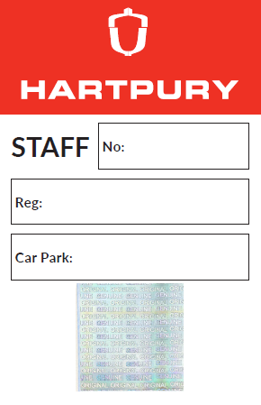 | Staff / Visitors / Corporation Members / Governors
Main Car Park | Residential Student Permit  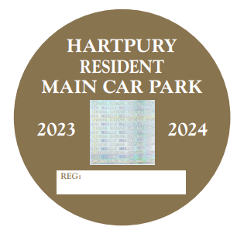 | Hartpury House, Catsbury Upper Limbury residential students
Rudgeley Staff Car Park | Residential Staff permit | Residential staff (Rudgeley Accommodation)
Equine Upper Car Park | Staff permit | Staff and visitors
Equine Upper Car Park | Non-resident Student Permit  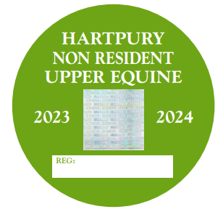 | Non-residential students
Equine Middle Car Park | Non-Resident Student Permit  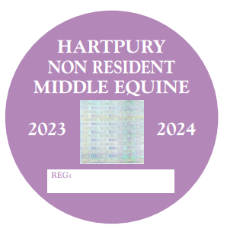 | Non–residential students
Equine Lower Car Park | Non-resident Student Permit  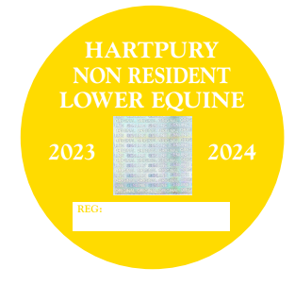 | Non–residential students
Home Farm – MW Centre car park | Staff Permit | Staff and visitors ONLY
Home Farm – student car park  Not available for 2023/24 | Non-resident Farm Student Permit  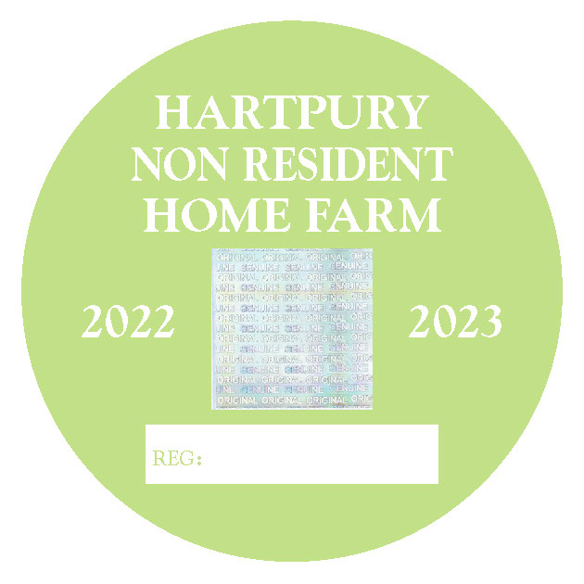 | Non-residential students ONLY
Sports Academy Staff Car Park SA 2 | Staff permit | Sports Academy Staff, sports officials & visitors
Hartpury  Sport Academy  Training Centre car Park | Non-resident Sport Academy Student  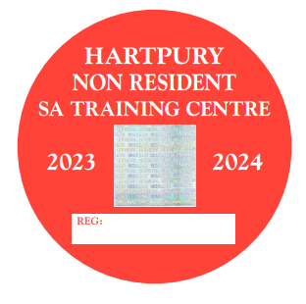 | Non-residental Student
Garden Cottage Car Park | Residential Staff permit  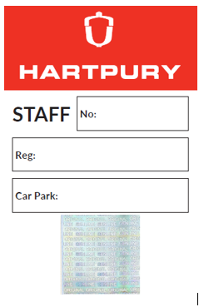 | Residential Staff (Garden Cottage) & College Vehicles
Hartpury Sport Academy Car Park | Non-Resident Student Permit   | Non-Residential Student
New Vicarage Car Park | Residential Student Permit  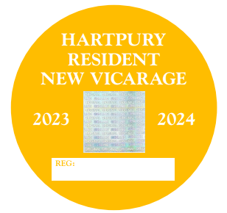 | New Vicarage and Limbury Residential Students
Main Car Park  Only | Postgraduate Parking Permit  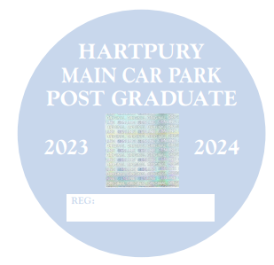 | Non-Residential Post Graduate

