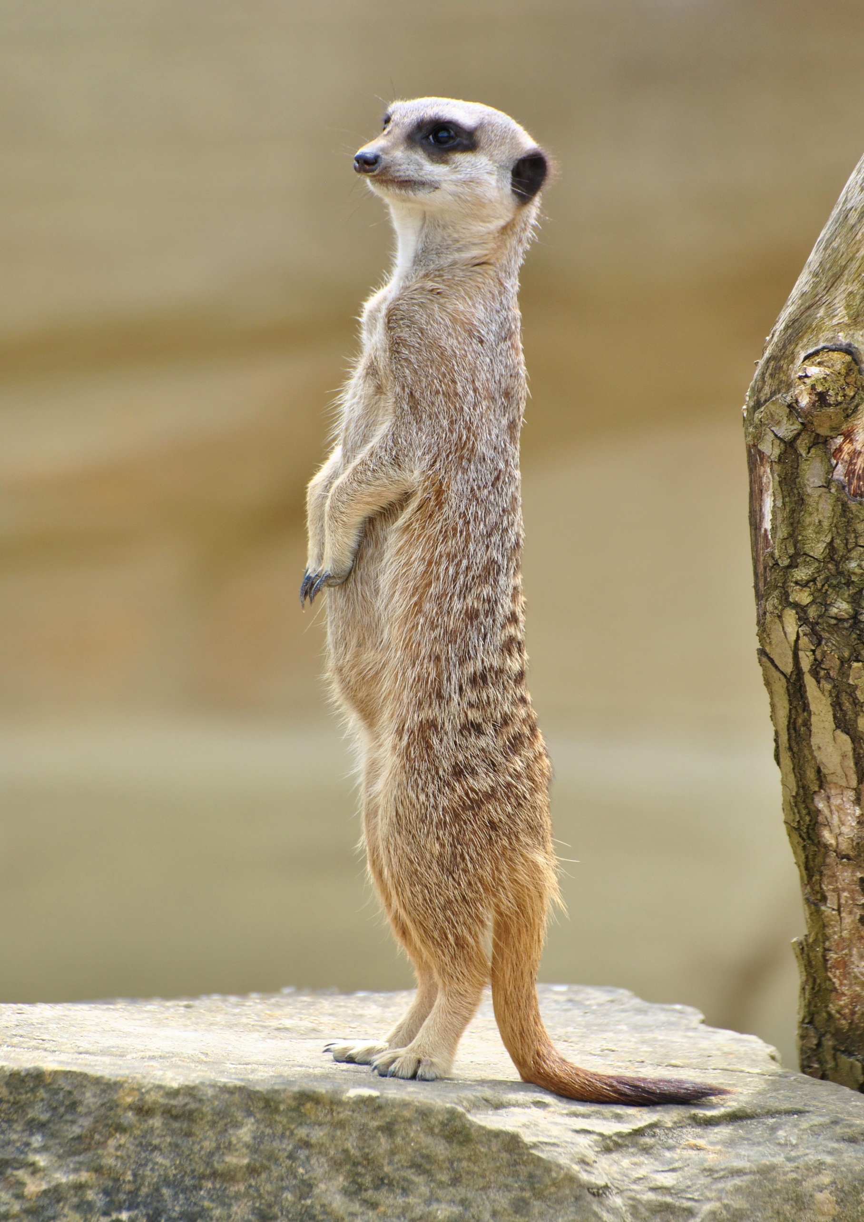

**Herbivore**

**Nocturnal**

**Nymph**

**Colony**

**Hibernation**

**Moult**

**Mimicry**

**Mammal**

**Frugivorous**

**Gill**

**Warm blooded vertebrates that have mammary glands, which means that the females are able to produce milk to feed their young. They are generally land-dwelling animals but there are exceptions like the blue whale.**

**When an animal sleeps for a long time, normally during winter months and in preparation, the animal spends the months before eating lots of food to make sure its body has enough energy to survive the winter.**

**When one animal attempts to camouflage itself by resembling another animal or an object such as a leaf or a stick.**

**The animal tends to sleep during the daylight hours and wakes up to hunt when night falls.**

**An animal that only eats plant material, algae and bacteria in order to gain its nutrition.**

**A young insect that is similar in appearance to it's parents but it does not yet have functioning organs or is able to fly.**

**A group of animals from the same species, that spend their lives together and often have individual tasks that help with the overall survival of the group.**

**An external organ used by aquatic animals such as fish, to extract oxygen out of the water.**

**The shedding of fur, feathers, scales and skin so that it can be renewed and replaced.**

**An animal that feeds on fruit.**

Match the Animal Key Terms

How many can you get right?