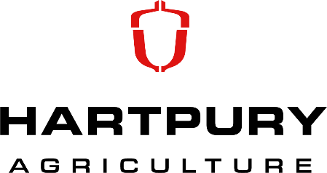

Agri-Tech
Types of Technology
Below are some examples of technology used in agriculture to produce our tasty British food!
Robotics  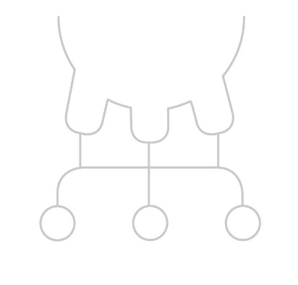 | Robotics and machines operating automatically are now becoming more popular in agriculture.  They can currently be used for:  - Feeding Livestock  - Milking Cows  New robotic ideas are created all the time so watch out for what’s next!
Management Software  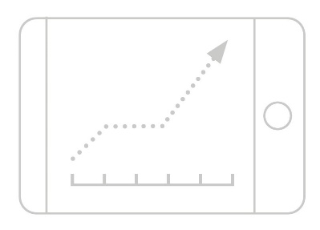 | No more need for pen and paper!  Farmers are now able to able to track and monitor all aspects of their farm production either on their phone, tablet or computer.  This allows easier management and to spot where things could be improved much earlier.
GPS  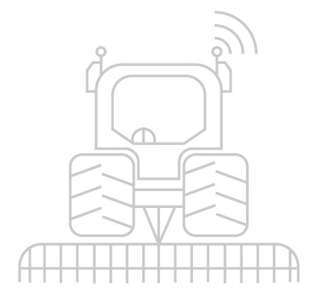 | GPS stands for Global Positioning System. It allows us with the use of a receiver and satellites to know exactly where we are located and also map a route or journey.  These receivers can be commonly found on tractors to carry out accurate driving in the field. This ensures all the land is covered with limited wastage  The accuracy of this can be down to as low as 3cm!
Precision Imagery | Satellites and drones can also be used to take birds-eye pictures of our fields.  Did you know they can be used to:  - Spot signs of disease or weeds  - Check how the crop is growing  - Notice some if the nutrient levels are too high or low
Livestock Sensors  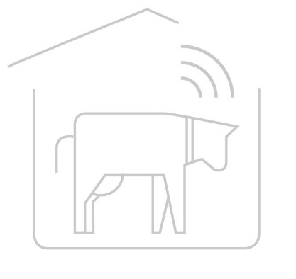 | Heard of FitBits?  These sensors are very similar to Fitbits but for farm animals. They can monitor:  - Temperature  - Activity  - Location  All this contributes to ensuring livestock have the best welfare and also so that any problems can be spotted as soon as possible!
Biotech | Biotech is the use of technology to contribute towards biosecurity measures and biological tasks.  Biosecurity is the control of pests and diseases, which can be very difficult to control, sometimes because it cannot even be seen.  Examples of Biotech include new medicines, chemical tests, substances and equipment.  This technology ensures our food security is as high as it can be and also protected.

