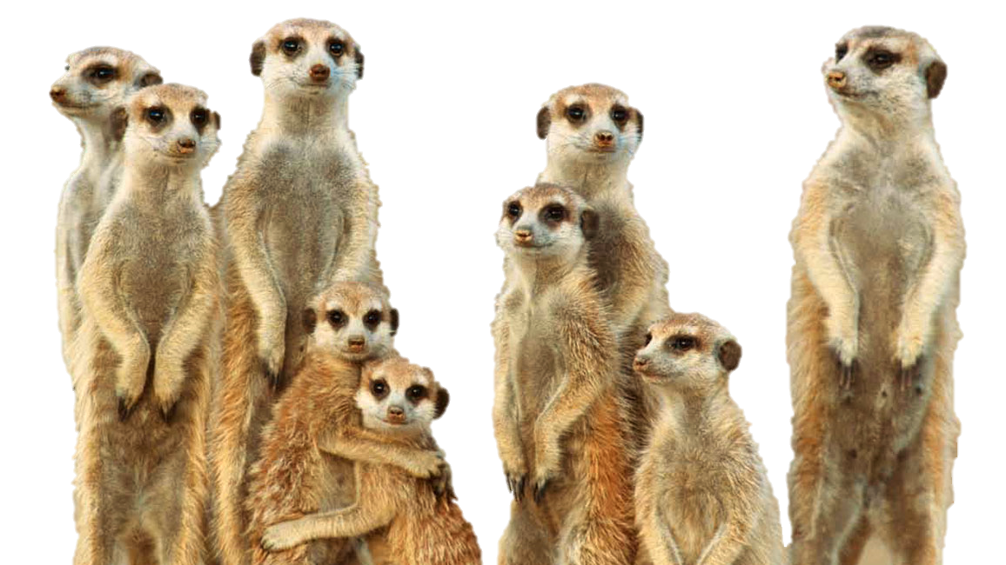

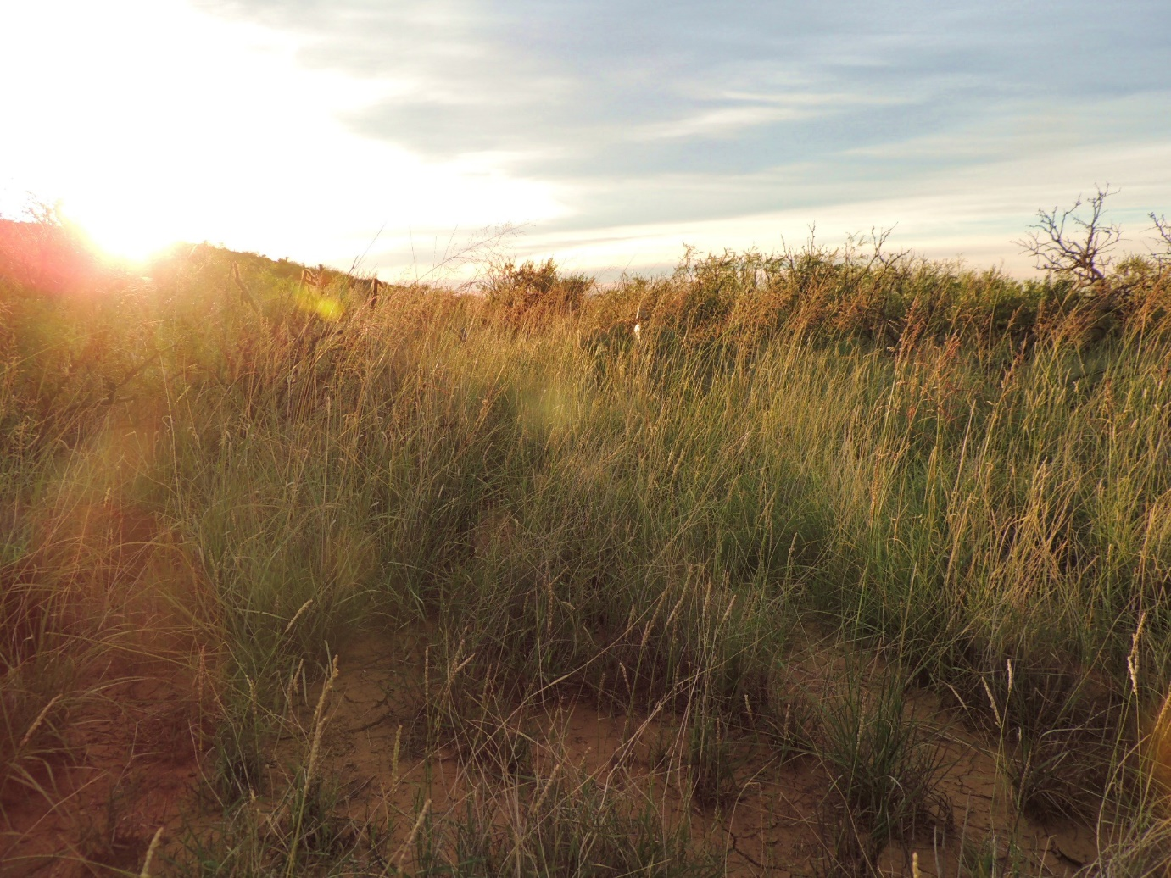

C | O | N | S | E | R | V | A | T | I | O | N | N | Y | O | N
W | B | T | H | E | R | A | P | Y | L | F | Q | Z | L | O | C
K | B | E | B | H | X | J | U | A | A | N | C | C | I | G | U
S | K | Y | H | Y | R | J | A | B | N | L | D | T | V | Z | G
G | C | Z | M | A | C | W | S | V | M | U | C | Y | E | K | Q
Z | N | O | Y | Z | V | E | C | B | O | E | D | Y | S | Y | U
H | I | I | H | I | I | I | A | G | L | L | H | W | T | R | W
M | I | K | N | C | F | V | O | L | I | M | N | W | O | K | N
N | J | W | E | I | K | D | O | U | E | H | D | L | C | Z | W
Q | H | P | A | U | A | C | T | E | R | J | H | Q | K | H | W
O | S | Q | N | L | L | R | R | R | E | S | E | A | R | C | H
P | K | F | W | A | Q | K | T | K | D | P | A | R | T | P | C
H | S | N | M | M | A | A | D | M | I | O | L | J | V | Q | A
G | I | I | D | T | E | X | S | N | S | Y | T | X | F | C | J
E | N | K | S | R | S | I | K | E | E | Q | H | R | I | F | V
A | M | O | A | M | T | O | K | J | A | U | Z | M | G | Z | Z
X | W | Y | A | E | E | D | B | B | S | G | W | I | C | S | V
T | F | I | E | B | A | L | W | W | E | L | F | A | R | E | T

Find these words:

Animal Collection
Behaviour
Conservation
Disease
Health
Livestock
Meerkats
Research
Species
Therapy
Training
Welfare
Write your name:
_____________________________________

