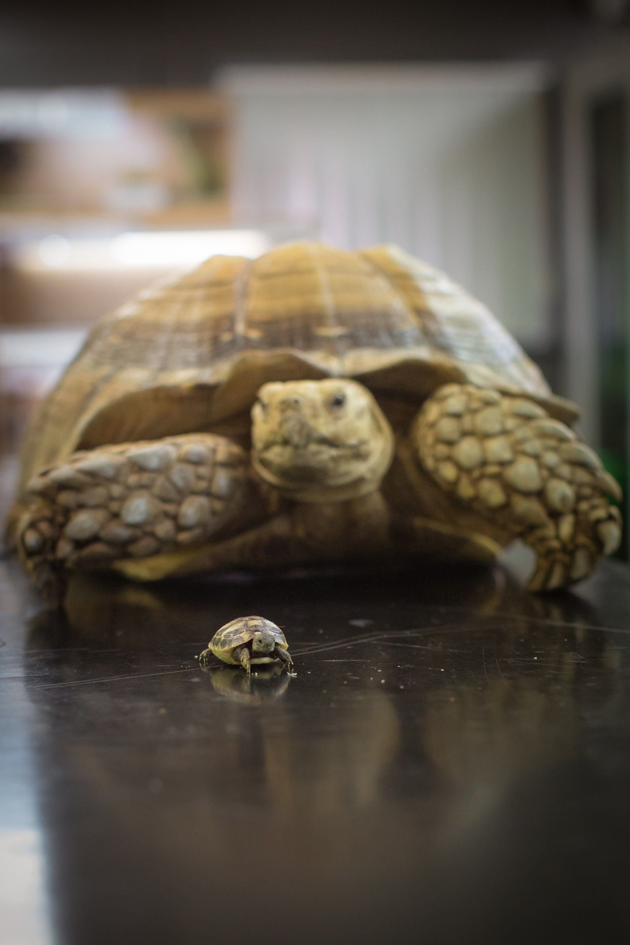

|  |  |  |  |  |  |  |  |  |  |  |  |  |  |  |  |  |  |  |  |  |  |  |  |  |
| --- | --- | --- | --- | --- | --- | --- | --- | --- | --- | --- | --- | --- | --- | --- | --- | --- | --- | --- | --- | --- | --- | --- | --- | --- |
| **H** | **Z** | **Z** | **K** | **Q** | **N** | **L** | **N** | **Q** | **D** | **E** | **E** | **N** | **E** | **Y** | **F** | **Y** | **H** | **S** | **A** | **Y** | **D** | **N** | **K** | **K** |
| **E** | **L** | **X** | **U** | **T** | **V** | **P** | **I** | **O** | **L** | **M** | **W** | **X** | **H** | **B** | **C** | **O** | **E** | **G** | **N** | **P** | **G** | **S** | **C** | **Q** |
| **R** | **H** | **P** | **V** | **X** | **K** | **U** | **G** | **K** | **I** | **A** | **E** | **T** | **O** | **Y** | **U** | **M** | **A** | **P** | **I** | **A** | **Z** | **C** | **O** | **S** |
| **Y** | **C** | **M** | **R** | **P** | **K** | **A** | **N** | **C** | **F** | **T** | **N** | **E** | **D** | **T** | **U** | **D** | **L** | **S** | **M** | **R** | **Z** | **K** | **T** | **Z** |
| **O** | **Y** | **P** | **R** | **A** | **G** | **Y** | **P** | **K** | **X** | **O** | **A** | **B** | **R** | **N** | **I** | **I** | **T** | **B** | **A** | **E** | **U** | **L** | **S** | **C** |
| **N** | **H** | **J** | **C** | **I** | **I** | **I** | **S** | **C** | **I** | **I** | **I** | **V** | **P** | **K** | **I** | **C** | **H** | **F** | **L** | **H** | **B** | **K** | **E** | **M** |
| **P** | **Y** | **U** | **L** | **Q** | **H** | **R** | **E** | **T** | **O** | **O** | **E** | **S** | **R** | **D** | **A** | **B** | **P** | **B** | **C** | **T** | **A** | **M** | **V** | **F** |
| **V** | **S** | **I** | **Z** | **R** | **W** | **R** | **I** | **H** | **V** | **G** | **I** | **U** | **E** | **E** | **D** | **T** | **D** | **M** | **O** | **O** | **G** | **R** | **I** | **F** |
| **Q** | **T** | **S** | **E** | **T** | **A** | **R** | **B** | **E** | **T** | **R** | **E** | **V** | **N** | **I** | **S** | **T** | **S** | **P** | **L** | **R** | **O** | **E** | **L** | **E** |
| **Y** | **X** | **U** | **L** | **F** | **T** | **D** | **T** | **Y** | **D** | **C** | **U** | **E** | **A** | **E** | **C** | **N** | **F** | **P** | **L** | **D** | **T** | **S** | **Y** | **Z** |
| **W** | **B** | **F** | **L** | **U** | **W** | **E** | **T** | **I** | **I** | **O** | **N** | **O** | **I** | **T** | **L** | **E** | **O** | **G** | **E** | **Y** | **G** | **E** | **P** | **S** |
| **K** | **W** | **E** | **N** | **D** | **R** | **R** | **V** | **V** | **Q** | **C** | **G** | **R** | **I** | **N** | **O** | **J** | **P** | **C** | **C** | **H** | **O** | **A** | **A** | **I** |
| **T** | **W** | **E** | **S** | **I** | **A** | **Y** | **E** | **K** | **V** | **P** | **O** | **S** | **N** | **V** | **P** | **X** | **T** | **S** | **T** | **K** | **A** | **R** | **R** | **L** |
| **D** | **T** | **I** | **N** | **I** | **D** | **O** | **M** | **E** | **S** | **T** | **I** | **C** | **Z** | **X** | **A** | **S** | **A** | **Q** | **I** | **B** | **T** | **C** | **E** | **B** |
| **V** | **X** | **A** | **N** | **P** | **V** | **O** | **U** | **Q** | **A** | **V** | **O** | **A** | **I** | **W** | **B** | **H** | **T** | **V** | **O** | **R** | **S** | **H** | **H** | **S** |
| **U** | **R** | **I** | **P** | **E** | **R** | **F** | **O** | **R** | **M** | **A** | **N** | **C** | **E** | **F** | **I** | **P** | **E** | **S** | **N** | **Y** | **D** | **K** | **T** | **X** |
| **Y** | **N** | **U** | **S** | **W** | **L** | **N** | **O** | **Y** | **G** | **O** | **L** | **O** | **H** | **C** | **Y** | **S** | **P** | **B** | **K** | **H** | **U** | **B** | **H** | **G** |
| **G** | **L** | **W** | **X** | **O** | **G** | **B** | **E** | **S** | **A** | **E** | **S** | **I** | **D** | **J** | **S** | **L** | **W** | **X** | **M** | **C** | **C** | **U** | **F** | **F** |
| **F** | **N** | **Z** | **A** | **S** | **A** | **Z** | **O** | **O** | **L** | **O** | **G** | **Y** | **P** | **I** | **N** | **X** | **D** | **R** | **X** | **N** | **Z** | **F** | **I** | **P** |
| **D** | **U** | **R** | **P** | **L** | **H** | **G** | **Y** | **V** | **N** | **Z** | **S** | **B** | **O** | **Q** | **L** | **E** | **X** | **Q** | **Q** | **J** | **L** | **Z** | **D** | **Q** |

**Animal Collection Bagot Goats Behaviour Bioveterinary Conservation**

**Disease Dog Agility Domestic Exotic Health**

**Hydrotherapy Invertebrates Laboratories Livestock Meerkats**

**Nutrition Performance Prairie Dogs Psychology Research**

**Species Therapy Training Welfare Zoology**

**Hartpury Animal**

**Word search**